CSC8503 Coursework 2022/23 – Alex Knight b190642042

Controls:

W/A/S/D – normal movement, relative to camera position

Q/E – Rotate goat

Spacebar – jump (requires ground contact)

Shift – goat dash (requires ground contact)

Left click – goat shove (on object in front of goat)

Right click – toggle goat grab (on object in front of goat)

Extra:

V – demonstrate OBB-sphere collision in front of goat

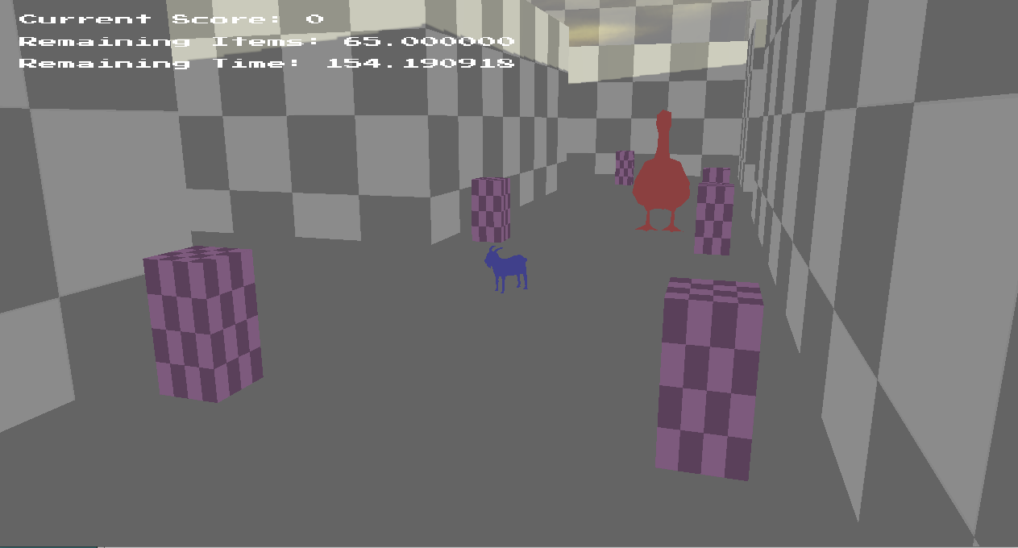

Displayed: The goose pursues the player through the maze.  
The goose operates on a behaviour tree, following any “noise” made by the goat colliding with objects in the maze or otherwise searching the maze. On detection of the player, the goose will pursue either until it has no line of sight for ten seconds, or it gets close enough to “attack”, lunging at the player.

Should the goose catch the player, points will be deducted and the two will be restored to their starting positions. The goose will resume its search.

Displayed: As the game timer runs out, the game automatically ends, in this case determining victory as the player has narrowly collected all items in time, whilst the goose is seen breaking through a barrier behind them. The game returns to its menu state, to restart or close the game.

Displayed: The goat bursting through a barrier of blocks with its goat-dash.  
Collisions work for AABB, sphere and capsule collisions, along with OBB-sphere collisions which may be demonstrated by pressing “V” to create a sphere and OBB in the air and collide them.  
This system also uses multiple coefficients of restitution, varied between objects.

Displayed: The goat dragging a key towards the maze door.  
This shows the use of constraints in gameplay, through the need to deliver an object to another to remove an obstacle. It may also be used to clear obstructions or drag a crate to jump on.

Displayed: The goat chasing after a farmer.

The farmer functions using state machines and superstates, the default superstate patrolling the world across several waypoints with pathfinding, and the alternate superstate based upon fleeing the goat or any other object that hits them at sufficient speed. This prioritises clearing distance, before self-righting if they have fallen over and waiting to resume patrol.